| **Document Name** | **Term Project Phase 3** |
| --- | --- |

| Project Name | Crazy Frog Online Food Delivery |
| --- | --- |
| Project Owner | Team 3 |
| Course Number | CIS 5800 |
| Submission Date | August 9th, 2021 |

**Team Members:**

| Name | Contact Info |
| --- | --- |
| Darya Filipchyk | darya.filipchyk@baruchmail.cuny.edu |
| Anastasiya Uraleva | anastasiya.uraleva@baruchmail.cuny.edu |
| Akane Yasutomi | akane.yasutomi@ baruchmail.cuny.edu |
| Munira Zulka | munira.zulka@baruchmail.cuny.edu |

**Table of Content**

Executive Summary --------------------------------------------------------------------------------------------------- Page 3

Project Background ----------------------------------------------------------------------------------------------------Page 5

Product Backlog --------------------------------------------------------------------------------------------------------Page 5

Sprint 1 ---------------------------------------------------------------------------------------------------------Page 8

Sprint 2 ---------------------------------------------------------------------------------------------------------Page 9

Burndown Chart --------------------------------------------------------------------------------------------------------Page 12

Deployment Plan--------------------------------------------------------------------------------------------------------Page 12

Product Environment ---------------------------------------------------------------------------------------- Page 12

Deployment Diagram ---------------------------------------------------------------------------------------- Page 14

Website Deliverables ----------------------------------------------------------------------------------------- Page 14

Database Deployment --------------------------------------------------------------------------------------- Page 17

Mobile Deliverables ------------------------------------------------------------------------------------------ Page 20

Rollout & Training Plan-------------------------------------------------------------------------------------- Page 22

Communication Plan ---------------------------------------------------------------------------------------- Page 23

Future Enhancements --------------------------------------------------------------------------------------- Page 24

Closeout Report -------------------------------------------------------------------------------------------------------- Page 24

Product Release -------------------------------------------------------------------------------------------------------- Page 26

Lesson Learned -------------------------------------------------------------------------------------------------------- Page 28

Project Team Meeting minutes -------------------------------------------------------------------------------------- Page 29

Project Repository ----------------------------------------------------------------------------------------------------- Page 31

# Executive Summary

Overview:

The food delivery business is a form of the system adopted by restaurants in the food industry. Crazy Frog is an online food delivery system that makes it possible for people to order food from their favorite restaurant that’s available on the business website. It is web-based and has mobile web integration that allows users to order their food online and wait for delivery of the food.

The Team:

| **Project Team / Stakeholders** | |
| --- | --- |
| Name / Title | Email |
| Darya Filipchyk / Project Manager | darya.filipchyk@baruchmail.cuny.edu |
| Anastasiya Uraleva /App Developer, UI Designer | anastasiya.uraleva@baruchmail.cuny.edu |
| Akane Yasutomi / Database Manager | akane.yasutomi@ baruchmail.cuny.edu |
| Munira Zulka / Web Developer | munira.zulka@baruchmail.cuny.edu |
| Mansukh Gobind /Financial Analyst | mansukh.gobind@baruchmail.cuny.edu |

Plan:

| **Begin Date:** | **End Date:** | **Project Duration:** |
| --- | --- | --- |
| 06/07/2021 | 08/09/2021 | 64 days |

| Weeks 1  Weeks 2 – 3  Weeks 4 – 6  Weeks 7 – 8  Weeks 9 | Term project proposal plan submission  Design, Analysis, and Implementation phases  Design and Analysis phase  Implementation and Maintenance phases  Presentations |
| --- | --- |

Budget Information:

The firm has allocated $125,000 for this project. The majority of costs will be internal labor for developing and deploying the application with state of the art features. The labor estimate is about 80 hours per week.

Our strategy is to provide:

* *Convenience:* Make it easy for customers to order food anywhere, anytime through the app. The website should be mobile optimized as well and load on any mobile device as on a desktop. To make the ordering process as easy and intuitive as possible.
* *Updated database:* It is important to maintain a database and update it regularly. We’ll ensure to remove old and redundant information to enhance the efficiency of the database as well as the app and website.
* *Innovation:* Users will be able to see meal size using AR technology.
* *Simplified checkout process:* The system should be able to save and store users’ credit cards numbers in order to make one-click payments at checkout.

Competitive Advantage:

* Live data on menu availability.
* Advanced ordering service.
* Coupons support.
* Live support.
* Use of AR technology.

Mission:

To create an environment where absolute customer satisfaction is the highest priority.

Software Development Approach:

*Scrum methodology*: works best for the restaurant applications that we are building because it allows us to break down the project into smaller iterations and continuously improve each step as more feedback is gathered.

# Project Background

The system is meant to present an online application and a website for Crazy Frog Restaurant that enables the end-users to register to the system online, select the food items of their choice from the menu list, and order food online. The system should present an interactive and up-to-date menu with all available options in an easy-to-use manner. The menu should include pictures as well as AR picture view. Customers can choose one or more items to place an order which will land in the cart. Customers can view all the order details in the cart before checking out. The customer should be able to enter a delivery address and contact information. The payment can be made through online mode or at the time of home delivery depending upon the customer’s choice and convenience. At the end, the customer gets order confirmation details. Once the order is placed it is entered in the database and retrieved in pretty much real time. This allows restaurant employees to quickly go through the orders as they are received and process all orders efficiently and effectively with minimal delays and confusion.

**Product Backlog:**

**Estimate** – Estimate approximately time (in days), the item will take to develop

**Status** – Indicates item status: To Do, In Progress, Done, On Hold, or Removed

**Priority** - 0 (very important) 1 (important) 2 (can be done in the future iteration)

| **ID** | **Product Backlog Item** | **User Story** | **Estimate (Days)** | **Priority** | **Sprint** | **Status** |
| --- | --- | --- | --- | --- | --- | --- |
| **CF001** | Create Account | As a user I want to be able to create an account so I could save all my information for faster checkout | 1 | 0 | 1 | Done |
| **CF002** | Log In | As a user I want to be able to login into my account, so i could use my saved information for a faster checkout | 1 | 0 | 1 | Done |
| **CF003** | Add/remove items | As a user I want to add/remove multiple food items so that I can specify what I want to order | 1 | 0 | 1 | Done |
| **CF004** | Payment type choice | As a user I want to have flexible online payment options so that I can choose any method of my choice | 1 | 1 | 2 | Done |
| **CF005** | Order repeat | As a user I want to be able to repeat my previous orders (with or without modifications) at the click of a button | 2 | 1 | 2 | Done |
| **CF006** | Contact delivery person | As a user I want to be able to contact the delivery person directly to know the delivery status | 0.5 | 0 | 2 | Done |
| **CF007** | List Popular Items | As a user, I want to view popular items and food photos of a restaurant so that I can better choose my food | 0.5 | 0 | 2 | Done |
| **CF008** | Experience rating | As a user I want to be able to rate my experience of ordering on a scale of 1 to 5 | 1 | 0 | 2 | Done |
| **CF009** | Online order status check | As a user I want to be able to see my order status online so I know when to expect the delivery | 0.5 | 0 | 2 | Done |
| **CF010** | Add tip online | As a user I want to be able to add tip online for a delivery person | 0.5 | 0 | 2 | Done |
| **CF011** | Create Customers Database | As a admin I want to have access to customers database so I could see customers performance and send them promotions | 5 | 1 | 1 | Done |
| **CF012** | Create Menu | As I a customers I want to be able to see restaurant’s menu | 1 | 0 | 1 | Done |
| **CF013** | Accept order | Aa an admin I want to be able to accept orders and send them to the kitchen so the food could be prepared | 1 | 0 | 1 | Done |
| **CF014** | Visualize Food Item in AR | As a customer, I want to visualize the food item on the menu in my room to have a better sense of how big the portion is. | 3 | 2 | 2 | To Do |
| **CF015** | Track Driver | As a customer I want to be able to see where my delivery guy is on the route to my address | 2 | 2 | 2 | To Do |
| **CF016** | Repeat orders | As a user I want to be able to repeat my previous orders at a click of a button | 0.5 | 0 | 2 | Done |
| **CF017** | Live Chat | As a user I want to be able to chat with the restaurant in real time through the system | 1 | 2 | 2 | To Do |
| **CF018** | Delivery Estimate | As a user I want to know how much time food delivery will take so that I know how much to wait | 0.5 | 0 | 1 | Done |
| **CF019** | Choose order type and time | As a user I want to be able to choose a delivery or pickup type of order as well as the time when I want it to be delivered or picked-up | 0.5 | 0 | 2 | Done |
| **CF020** | Food Category | As a user I want the food to be split in categories in order to speed up the searching process | 1 | 0 | 2 | Done |
| **CF021** | Daily specials | As an admin I want to be able to list daily food specials and put them on top of the page to attract customers | 1 | 2 | 2 | Done |
| **CF022** | Promotions | As an admin I want to be able to attract more customer by sending them discount coupons via email | 1 | 2 | 2 | To Do |
| **CF023** | Display Order Summary | As a user a I want to be able to see my order summary on a right side upper corner while searching for other items | 2 | 2 | 2 | Done |
| **CF024** | Technical support | As a user I want to be able to contact customer support via chat or phone whenever I experience technical difficulties | 1 | 1 | 2 | Done |
| **CF025** | Delivery instructions | As a user I want to be able to list delivery instruction for a delivery guy | 1 | 0 | 1 | Done |

**Sprint 1**

| **ID** | **Product Backlog Item** | **User Story** | **Task** | **Task Owner** | **Estimate (Days)** | **Actual (Days)** | **Status** |
| --- | --- | --- | --- | --- | --- | --- | --- |
| **CF001** | Create Account | As a user I want to be able to create an account so I could save all my information for faster checkout | Create Account | Ana,  Munira | 1 | 1 | Done |
| **CF002** | Log In | As a user I want to be able to login into my account, so i could use my saved information for a faster checkout | Create Login Page | Ana,  Munira | 1 | 1 | Done |
| **CF003** | Add/remove items | As a user I want to add/remove multiple food items so that I can specify what I want to order | Add/remove items to the cart | Ana,  Munira | 1 | 2 | Done |
| **CF011** | Create Customers Database | As a admin I want to have access to customers database so I could see customers performance and send them promotions | Create Customers Database | Akane | 5 | 3 | Done |
| **CF012** | Create Menu | As I a customers I want to be able to see restaurant’s menu | Create Restaurant’s Menu | Ana,  Munira | 1 | 1 | Done |
| **CF013** | Accept order | Aa an admin I want to be able to accept orders and send them to the kitchen so the food could be prepared | Accept order from customers | Ana,  Munira | 1 |  | Done |
| **CF018** | Delivery Estimate | As a user I want to know how much time food delivery will take so that I know how much to wait | Estimate delivery time | Ana,  Munira | 0.5 |  | Done |
| **CF025** | Delivery instructions | As a user I want to be able to list delivery instruction for a delivery guy | Put delivery instruction section | Ana,  Munira | 1 |  | Done |

**Sprint 2**

| **ID** | **Product Backlog Item** | **User Story** | **Task** | **Task Owner** | **Estimate (Days)** | **Actual (Days)** | **Status** |
| --- | --- | --- | --- | --- | --- | --- | --- |
| **CF004** | Payment type choice | As a user I want to have flexible online payment options so that I can choose any method of my choice | Be able to choose payment type | Ana,  Munira | 1 | 2 | Done |
| **CF006** | Contact delivery person | As a user I want to be able to contact the delivery person directly to know the delivery status | Create a Contact Driver option | Akane | 0.5 | 0.5 | Done |
| **CF007** | List Popular Items | As a user, I want to view popular items and food photos of a restaurant so that I can better choose my food | List Popular Items | Ana,  Munira | 0.5 | 0.5 | Done |
| **CF008** | Experience rating | As a user I want to be able to rate my experience of ordering on a scale of 1 to 5 | Create a Rate experience option | Ana,  Munira | 1 | 0.5 | Done |
| **CF009** | Online order status check | As a user I want to be able to see my order status online so I know when to expect the delivery | Be able to check order status | Ana,  Munira | 0.5 | 1 | Mobile: Not Done |
| **CF010** | Add tip online | As a user I want to be able to add tip online for a delivery person | Add tip to the bill | Ana,  Munira | 0.5 | 0.5 | Done |
| **CF014** | Visualize Food Item in AR | As a customer, I want to visualize the food item on the menu in my room to have a better sense of how big the portion is. | Create AR | Ana | 3 | 4 | Not Done |
| **CF016** | Repeat orders | As a user I want to be able to repeat my previous orders at a click of a button | Create an option to repeat previous orders | Ana,  Munira | 0.5 | 0.5 | Done |
| **CF019** | Choose order type and time | As a user I want to be able to choose a delivery or pickup type of order as well as the time when I want it to be delivered or picked-up | Create selection of time, delivery or pick-up | Ana,  Munira | 0.5 | 0.5 | Done |
| **CF020** | Food Category | As a user I want the food to be split in categories in order to speed up the searching process | Divide food by category | Ana,  Munira | 1 | 1 | Done |
| **CF021** | Daily specials | As an admin I want to be able to list daily food specials and put them on top of the page to attract customers | Create daily specials section | Ana,  Munira | 1 | 1 | Done |
| **CF023** | Display Order Summary | As a user a I want to be able to see my order summary on a right side upper corner while searching for other items | Display Order Summary | Ana,  Munira | 2 | 1 | Done |
| **CF024** | Technical support | As a user I want to be able to contact customer support via chat or phone whenever I experience technical difficulties | Create technical support option | Ana,  Munira | 1 | 0.5 | Mobile: Not Done |

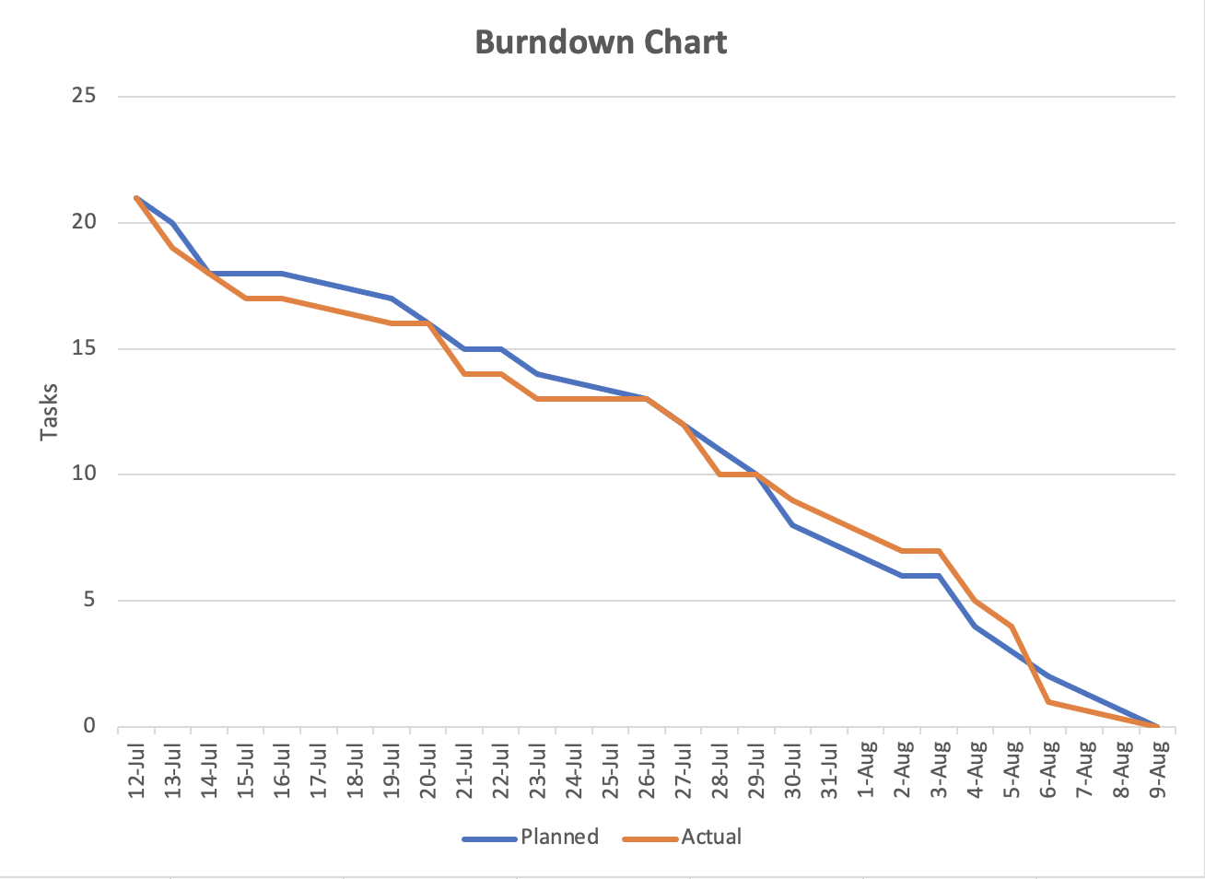

# Deployment Plan

**Production Environment:**

| **Production Environment:** | **Description:** | **Cost:** |
| --- | --- | --- |
| **App Production Softwares:** |  |  |
| XCode | Apple's integrated development environment for macOS, used to develop software for macOS, iOS, iPadOS, watchOS, and tvOS. | $0.00 |
| SwiftUi | Builds great-looking apps across all Apple platforms with the power of Swift — and as little code as possible | $0.00 |
| Github | Provider of Internet hosting for software development and version control using Git. It offers the distributed version control and source code management functionality of Git, plus its own features. | $0.00 |
| Figma | Figma is a vector graphics editor and prototyping tool which is primarily web-based, with additional offline features enabled by desktop applications for macOS and Windows. The Figma Mirror companion apps for Android and iOS allow viewing Figma prototypes in real-time on mobile devices. | $0.00 |
| **App Production Hardware:** |  |  |
| Mac M1 |  | $0.00 |
| **Website Production Softwares:** |  |  |
| Microsoft Visual Studio | Integrated development environment from Microsoft. It is used to develop computer programs, as well as websites, web apps, web services and mobile apps. | $0.00 |
| **Website Production Hardware:** |  |  |
| Mac M1 |  | $0.00 |
| **Database Production Softwares:** |  |  |
| VScode | source-code editor. Features include support for debugging, syntax highlighting, intelligent code completion, snippets, code refactoring, and embedded Git. | $0.00 |
| XAMPP | Open-source cross-platform web server solution stack package developed by Apache Friends, consisting mainly of the Apache HTTP Server, MariaDB database, and interpreters for scripts written in the PHP and Perl programming languages. | $0.00 |
| MySQL | Open-source relational database management system. Consists of a multithreaded SQL server that supports different back ends, several different client programs and libraries, administrative tools, and a wide range of application programming interfaces (APIs). | $0.00 |
| **Database Production Hardware:** |  |  |
| Mac M1 |  | $0.00 |

**Deployment Diagram:**

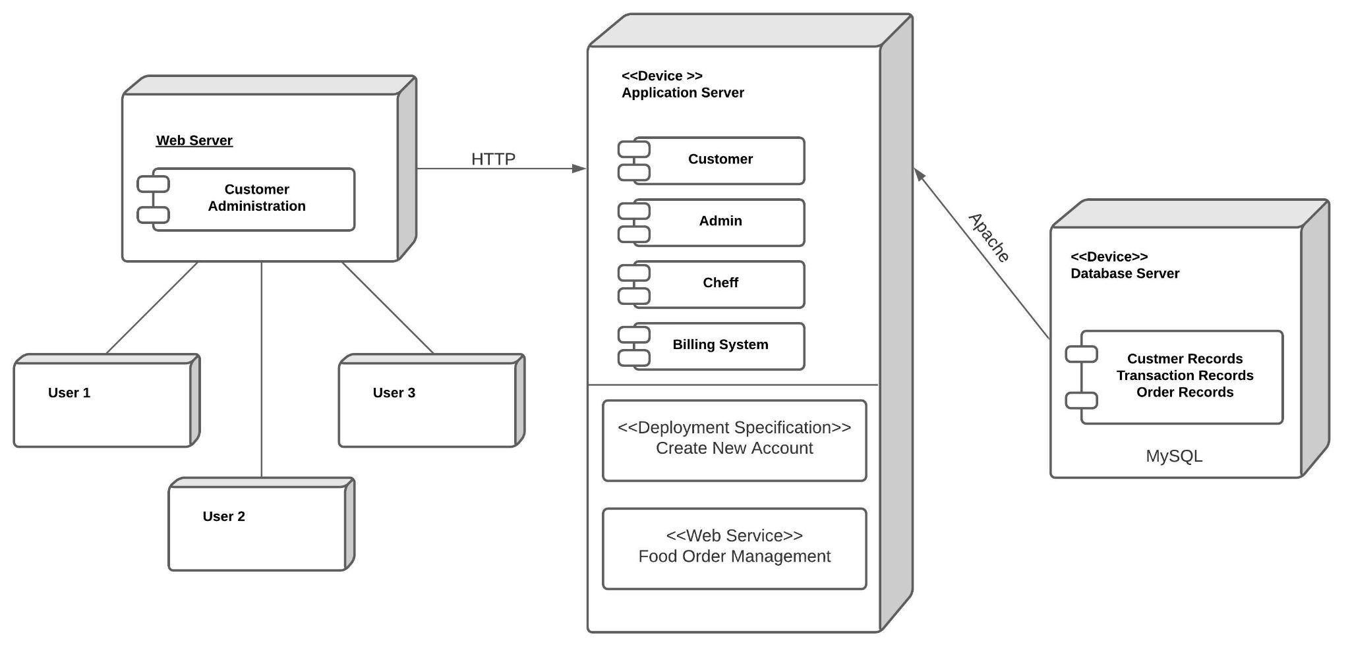

### **Website Deliverables:**

When creating the website, our goal was to make it easy to navigate and give no difficulty to customers. We all know how annoying it can get when you are very hungry and try to get something to eat but cannot easily navigate around a restaurant’s website. So, at Crazy Frog, we wanted to avoid that.

On our home page, you can find every tool you need. At the top header you can find links to different pages. Depending how you want to navigate the website. I have attractive pictures of food which are there to catch the eyes of our customers and make them look no further. At the bottom you can find buttons that either continue you to the next step or take you back to the previous page to help you navigate easily when needed.

At the top header, when you click “MENU” it takes you to the Menu page where you can browse a variety of dishes and choose how many orders you would like to place for each meal. Here, I used a built-in html feature and chose from 1 to 100 so that customers can order anywhere between A food item to 100 though I doubt a customer will put in that many orders on one food item unless it is for a catering event which will then be ordered on the app or by phone. With this feature, I wanted to use jQuery in JavaScript but after a little research I found out about this feature in html which was introduced only a few years ago. All the accessible features at the page so that the customer can still access them on every page without having to use the browser arrow.

On the

On the contact us page you can see that we have all the features for you to reach our restaurant with any questions whatsoever. And there is the Login page where you can login with your existing account feature.

From every page, I connected the next page and created multiple css files for certain pages that needed it. For some pages I connected 2 css files which worked perfectly fine. In the future I will work on consolidating that or have a built in css file to make things look cleaner.

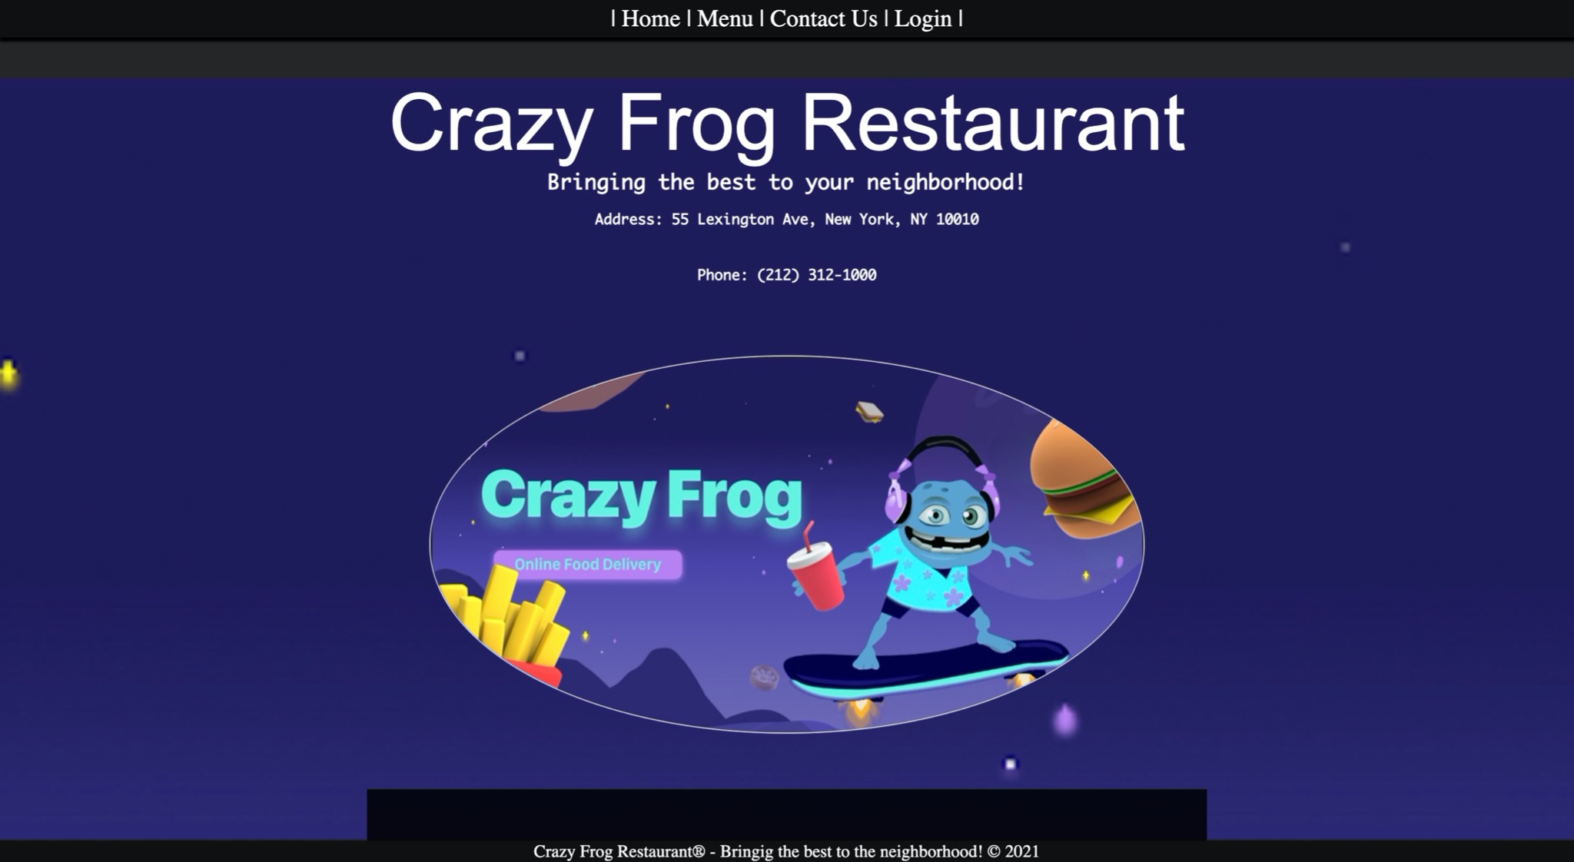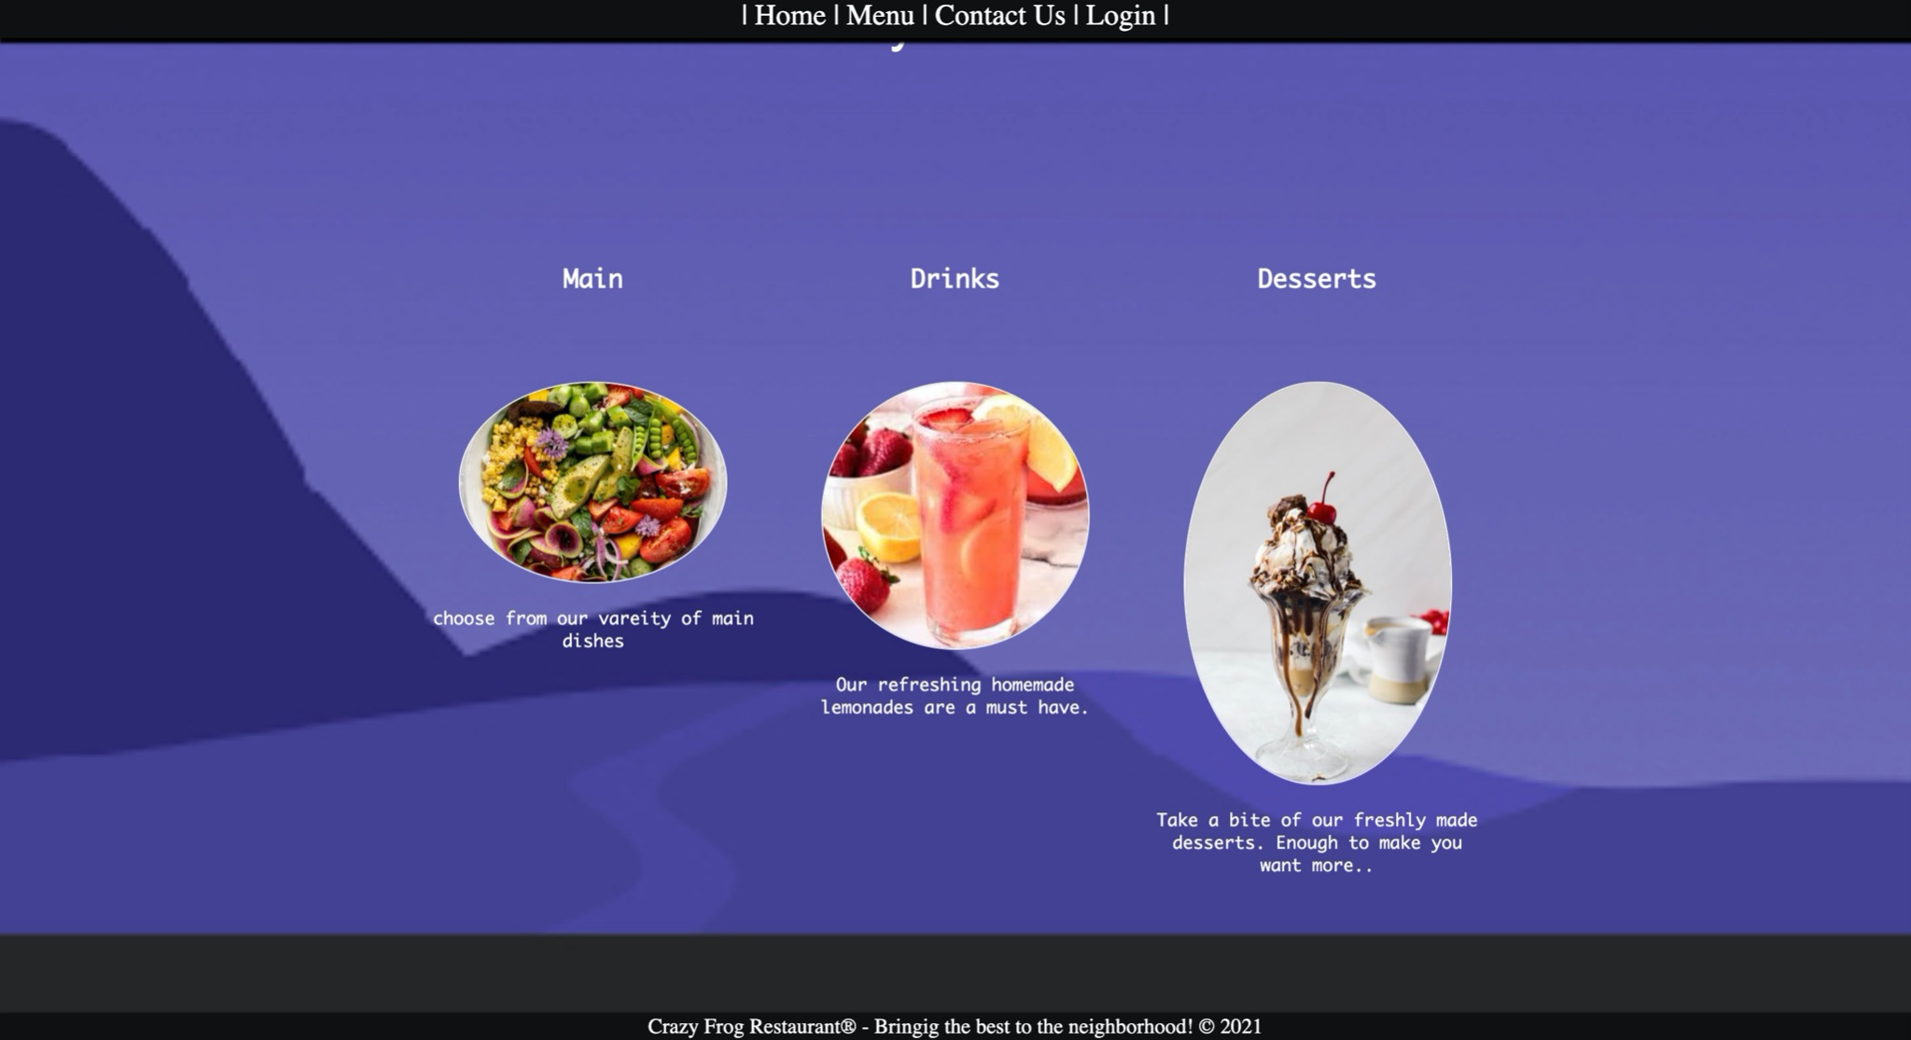

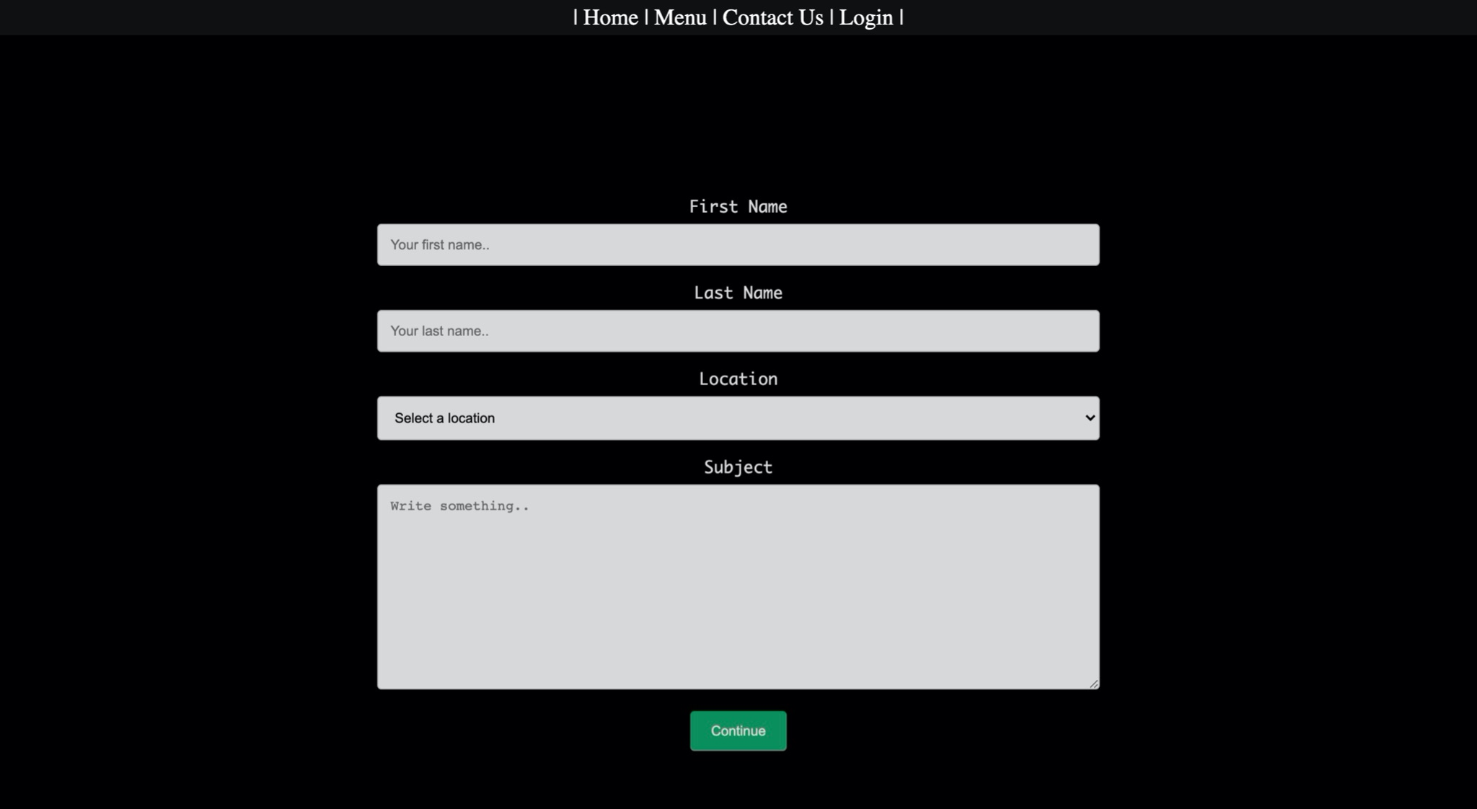

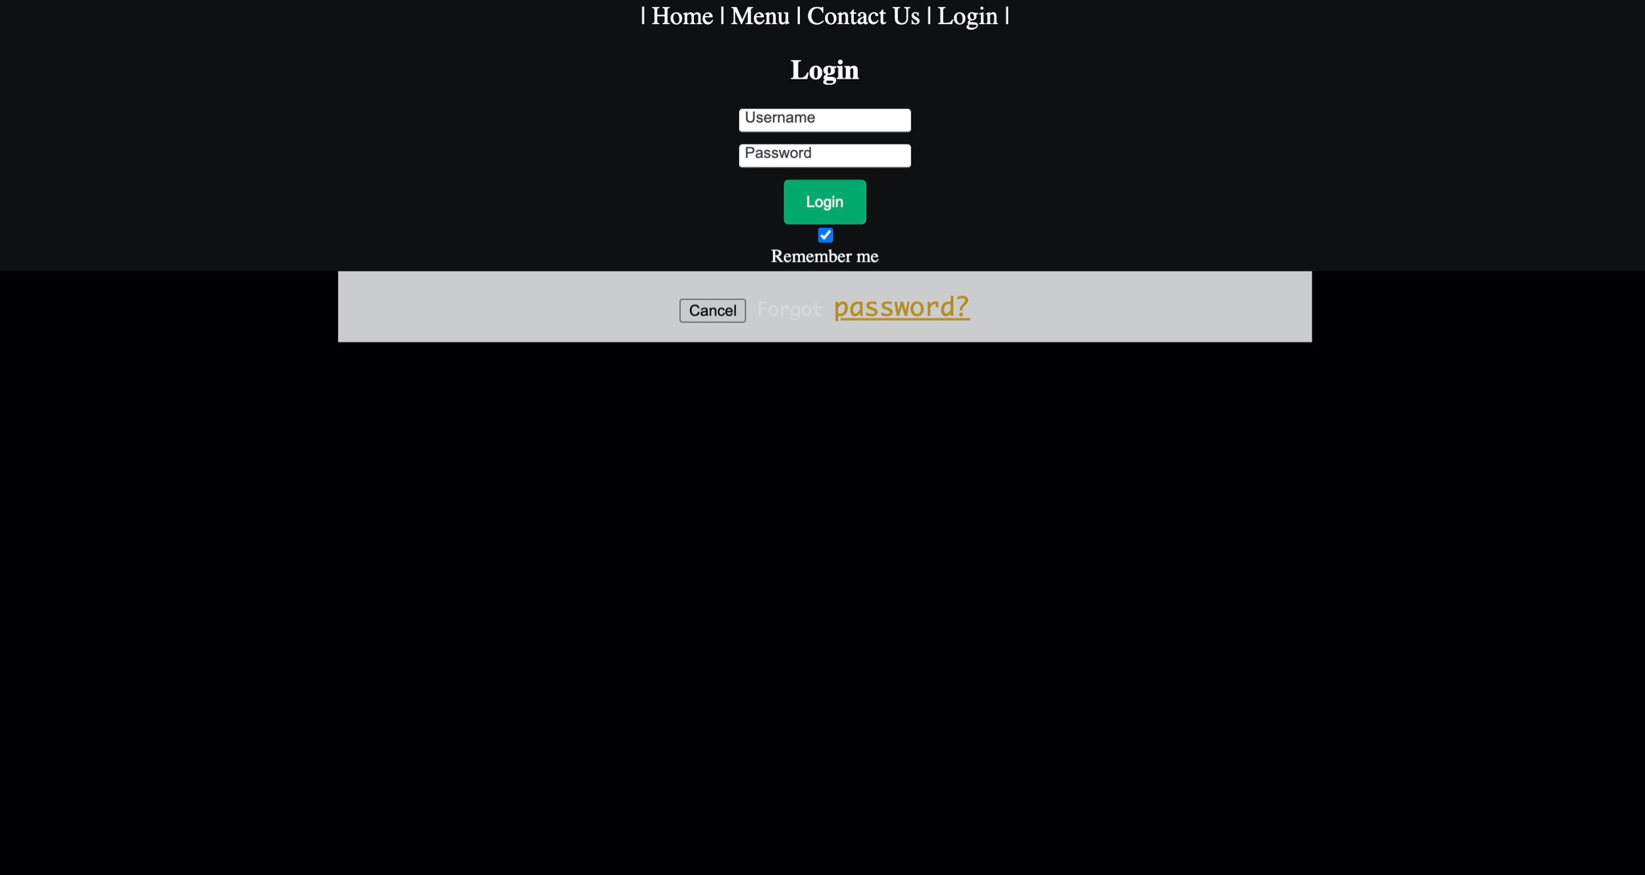

## **Database Deployment**:

To allow restaurants to stay organized and securely store customer information, we developed databases using Visual Studio Code, XAMPP, and MySQL, which are all free resources and open to everyone. We decided to use these tools because our budget is very tight and using free resources allows us to utilize our limited resources. Below is the process we followed to create databases for crazy frog.

**Number 1: MySQL database**

These are the queries we used to create one database and two tables in it.

CREATE DATABASE crazy_frog;

CREATE TABLE customer_info (

customer_id int auto_increment,

first_name varchar(20) not null ,

last_name varchar(20) not null ,

zip_code int not null ,

state varchar(10) not null ,

city varchar(64) not null ,

street_address varchar(50) not null ,

mobile int not null ,

email varchar(64) not null ,

primary key (customer_id)

);

CREATE TABLE card_info (

card_id int auto_increment,

name varchar(50) not null,

card_number varchar(50) not null,

expire_date varchar(255) not null,

security_code int not null,

primary key (card_id)

);

**Number 2: MySQL database (following)**

These screenshots below show a database and tables created during the development process. Both tables contains data that was saved during presentation demo.

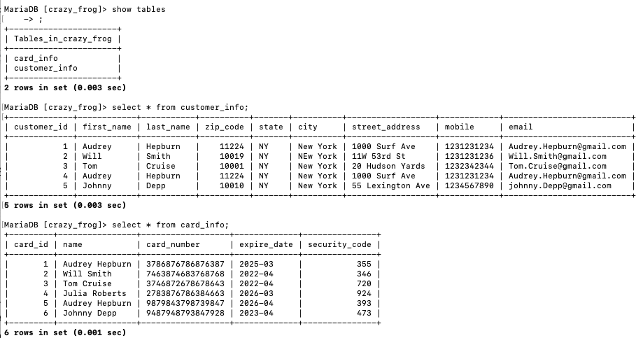

**Number 3: phpmyadmin**

You can also check the dataset from phpmyadmin and here is what you can find there. Same as MySQL, there is one database (“crazy_frog”) and two tables (“customer_info” and “card_info”). This organized database helps restaurants if they want to analyse data in order to expand their business or research for marketing purposes. For future reference, we are planning to add auto-fill functions that allow returning customers to skip the process to fill out customer and billing information. Since our time and budget are limited, we ask every customer including new and returning customers to fill out that information every time they order food on our website for now.

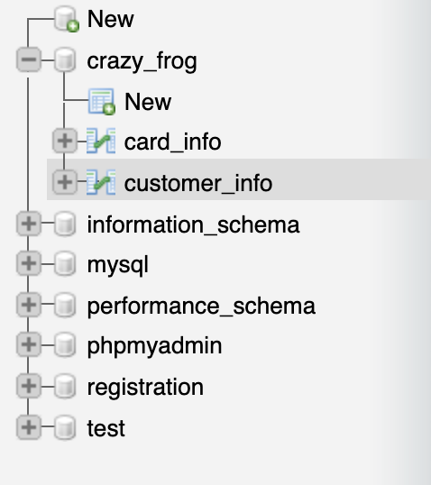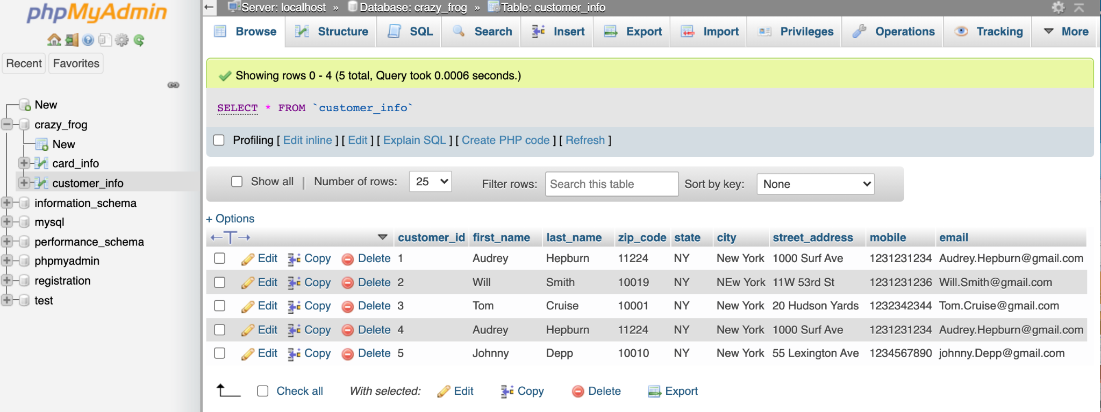

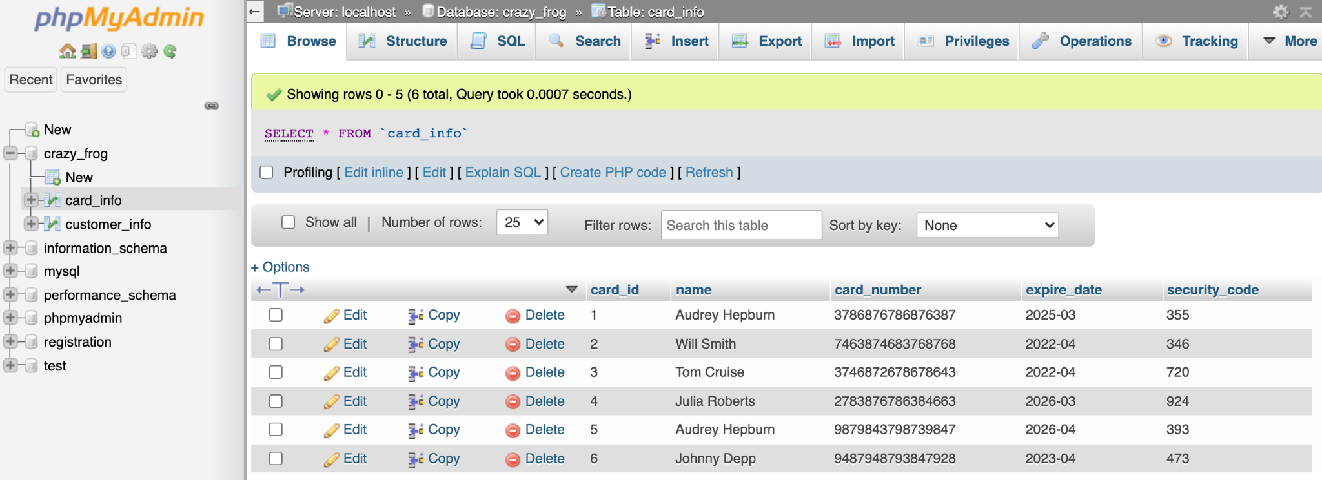

**Mobile Deliverables:**

To allow the Crazy Frog customers to order their food through the comfort of their home, the mobile app is an additional product that caters to this need. This mobile app is crucial because if Crazy Frog only has a website, it will prevent users who are currently traveling or don’t have access to their desktop to order food with a seamless experience. Thus, for the MVP the app has been created for the native IOS users using SwiftUI language and XCode developer tool

Our mobile app development process followed the Agile Scrum methodology. During the project period, we have completed a total of 2 Sprints to complete our MVP. Here is the breakdown of the screens that have been completed and the use cases behind them.

**Screen 1:** Log in Screen (completed during Sprint 1)

This screen allows the user to login to the app. Due to time constraints, this login view does not link to a real database like the website does. Our success criteria for this screen was to see how the user would login if the database was in fact working and if the user experience was intuitive.

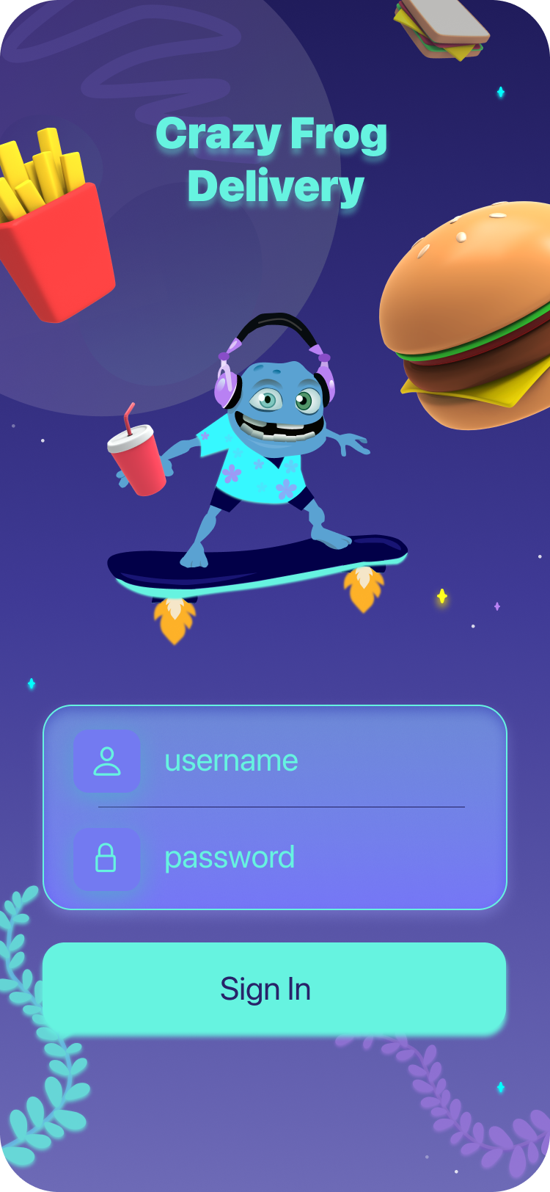 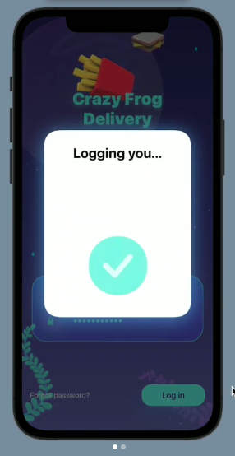

**Screen 2**: Main View Screen (completed during Sprint 1)

This view allows the user to get a glimpse of the popular food items in the restaurant.

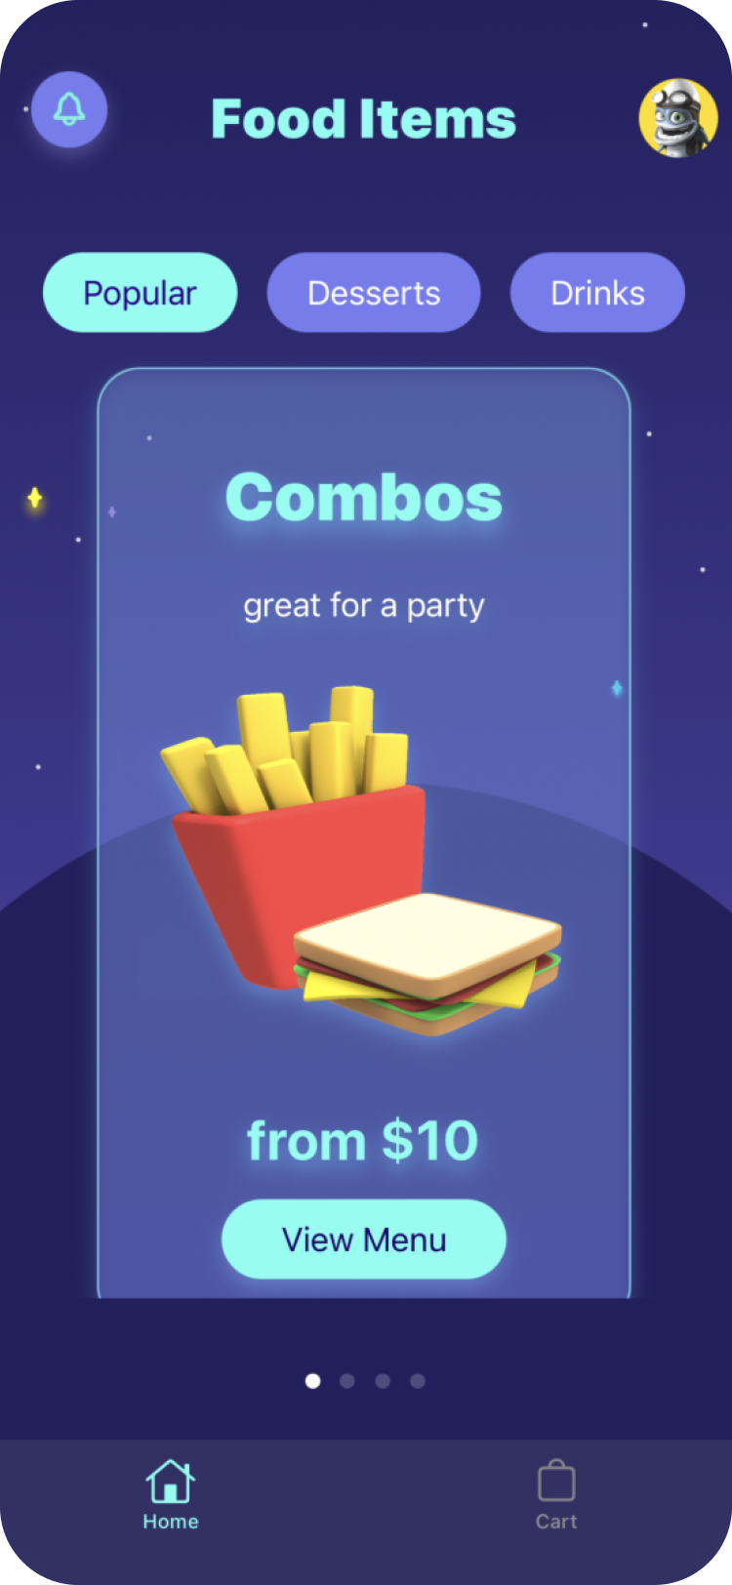

**Screen 3:** Menu View Screen (completed during Sprint 2)

This view allows the user to check which food options are available for the chosen category of the food.

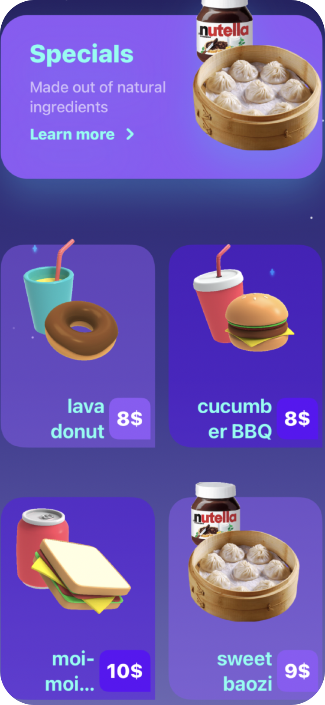

**Screen 4**: Detail of the Food Item Screen (completed during Sprint 2)

This view allows the user to learn more about what this food item is about and its ingredients. The user is also allowed to add the item to their shopping cart to later purchase it.

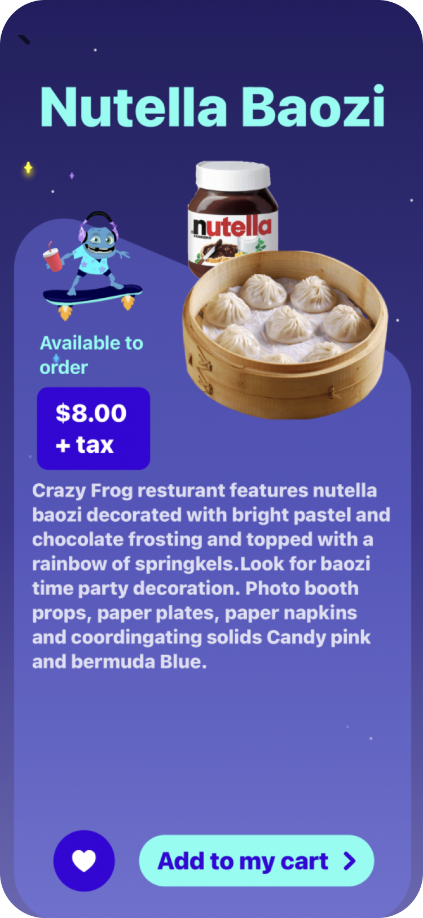

**Screen 5:** Shopping Cart Screen (completed during Sprint 2)

This view allows the user to check what items the user has saved and what quantity he wants to purchase. 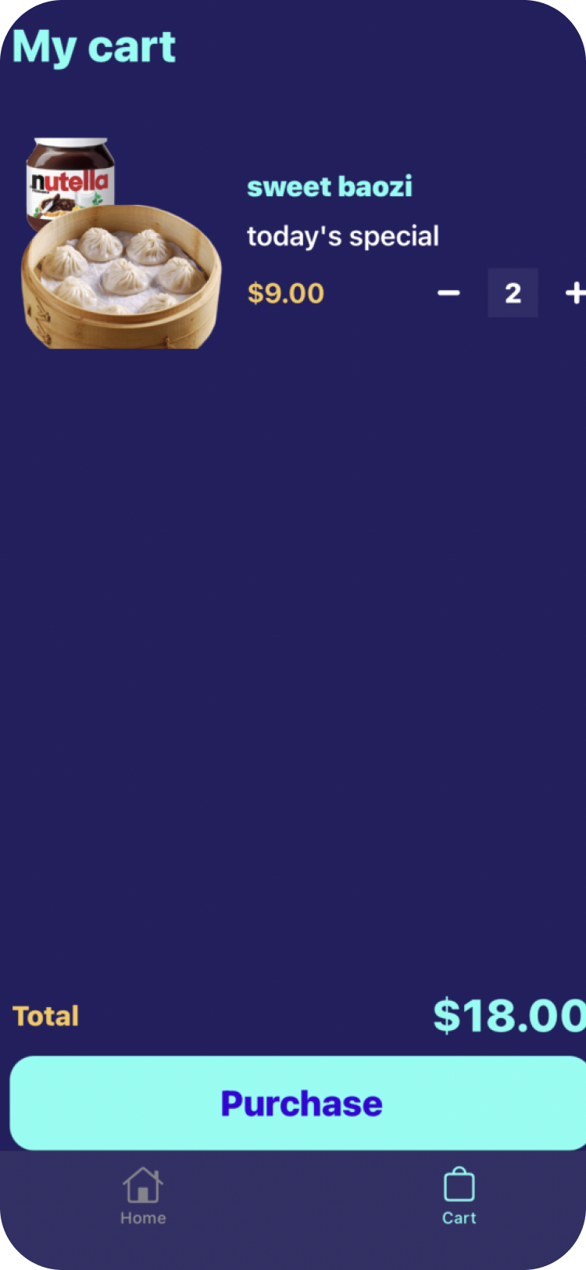

**Training & Rollout Plan:**

| **Demonstration:**  Perform tasks in front of the restaurant’s employees.  Create a group of three to four people and assign them a mentor. Trainees will observe them and later replicate the same. Moreover, the demonstration should include:   * Simple orders. * Custom orders and orders with special instructions. * Station duties and their Impact. |
| --- |
| **Practical Training:**  Gather the staff and let them use the restaurant online ordering system so that they can understand how it works. This way it will be easier to walk them through the process of ordering food online. Make them place test orders to understand more about customization orders. This will make them confident in handling customized orders when needed. |
| **Technology:**  People mostly rely on food ordering mobile apps. To ensure good returns, staff should be taught about the latest technology. Make the team familiar with the POS system, mobile ordering, feedback app and more. This will make them efficient in performing their duties.  Visual training modules will be used to train the staff. |
| **Communicate the Benefits:**  Tell the restaurant’s employees how they will benefit from the new technology. They will accept it with open arms when they see it will simplify their work. They can expect online orders to provide them faster turnover, call-in orders, satisfied customers and more. |
| **Create a Script:**  Create a script for the staff that they can use with customers. Ask them to keep the printed script handy at cashier and service stations, so that they can refer to it anytime. |
| **Differentiate Between in-house Tickets and Online:**  The restaurant’s staff should know how to differentiate between an in-house order and an online order placed via an online food ordering system or website. If a ticket printer cannot differentiate between the two, then they need to highlight one type of order. For instance, they can color the in -house orders. |
| **Cross-training:**  Train the staff about all the positions. It should be beneficial for the restaurant. This way, employees will come to know each other’s responsibilities, which would promote teamwork and make them more efficient. For instance, if the designated person is on leave, then another person can fill that person’s position. |

**Communication Plan:**

After the staff and the key actors in the system are trained with the new system, the communication plan would have a few parts.

The first part is that 1 month before the official mobile and website release, the project manager will again present to the internal stakeholders all product components that will be released. The key step here is to inform the internal stakeholders that if they notice any bugs in the software, which developers they should contact. During this step, the project manager will also communicate closely with the developers who will keep a live analysis of the traffic (which can be done using Google Analytics) that will slowly start to appear in both the website and the mobile app and inform Crazy Frog Restaurant if there are any emergency features that need to be taken down.

The 2nd part of the communication plan is to send out emails to all the customers about the mobile and website product launches during the release week. At this step, the marketing team of Crazy Frog is the one in charge to come up with the right language and content in order to tell the customers about these new products. The emails will also include links to surveys where the customers can optionally give their feedback about the 2 products that were recently released.

**Future enhancements:**

| **Order through virtual assistance.**  Create a bot for Facebook messenger and name it Crazy Frog, so customers could message Crazy Frog and request food with a single word or emoji. Crazy Frog also may reply to customer inquiries about vouchers and the latest deals.  Integrate with Alexa, Amazon’s virtual assistant. This new feature would let customers reorder any of their last three purchases on the Crazy Frog restaurant’s website. When a customer tells Alexa what they want to order, Alexa should place the order and announce the estimated delivery time. |
| --- |
| **Order with smartwatch:**  Interest in smartwatches is increasing: every year around 150 millions of smartwatches are sold in the US. This is why Crazy Frog Restaurant’s food delivery platform should be integrated with Android and Apple smart devices so that customers could order meals from their wrists in a few clicks. |
| **Order with a smart TV:**  Let people order food right from their TVs while laying in bed and relaxing. Crazy Frog restaurant wants to make ordering its food as fun and easy as streaming a movie. With a smart TV, a customer should be able to browse the entire menu, build a custom order, see favorites and past orders, and check out in one tap. The restaurant also will present exclusive Smart TV discounts for each order. |
| **Deliver food with drones:**  Drones can avoid traffic congestion and traffic lights and safely reduce the delivery time and distance by traveling directly to customers’ homes. |

# Project Closeout Report

Summary of the project goals and objectives, success criteria, actual performance, variances, and lessons learned

1) Project Objectives – List the related goals of the project as per Project Phase 1

2) Success Criteria – Specify the measurable criteria that will determine the success of the goal as per \ Project Phase 1

3) How Met – Briefly describe with evidence to verify and validate how success criteria were met

4) Variance – Explain any difference between planned vs. actual performance

| **Project Title:** | **Crazy Frog Online Food Delivery System** | **Date Prepared: 08/09/2021** | **Project Manager:** | **Darya Filipchyk** |
| --- | --- | --- | --- | --- |
| **Goal** | **Project Objectives** | **Success Criteria** | **How Met** | **Variance** |
| Scope | Create 2 working software applications (mobile and web) | 100% criteria met | Both apps work as expected |  |
| Schedule | 9 weeks | 100% criteria met | Product is delivered on time |  |
| Cost | 125,000 | 100% criteria met | Met the budget |  |
| Quality | follow the software development lifecycle | 98% criteria met | All the cycles were fully followed except the Analysis phase where not all the diagrams were used for the project. | State machine diagram was never used |

# 

# 

# 

# 

# 

**Product Release:**

**Product Release 1: Website**

* Our website was coded with HTML and CSS as well as PHP for the backend for the database. The code to both the website (HTML & CSS) and the PHP Database code is submitted with this project.

**Product Release 2: IOS Mobile App**

Our IOS Mobile App is publicly published on **Github**: <https://github.com/APiligrim/crazyFrog> . In addition, we have attached the coding project folder with this project submission.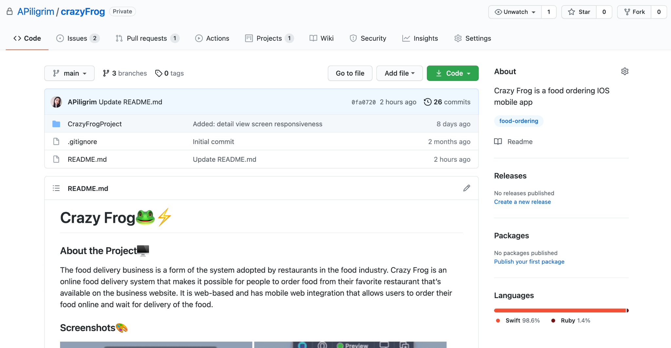

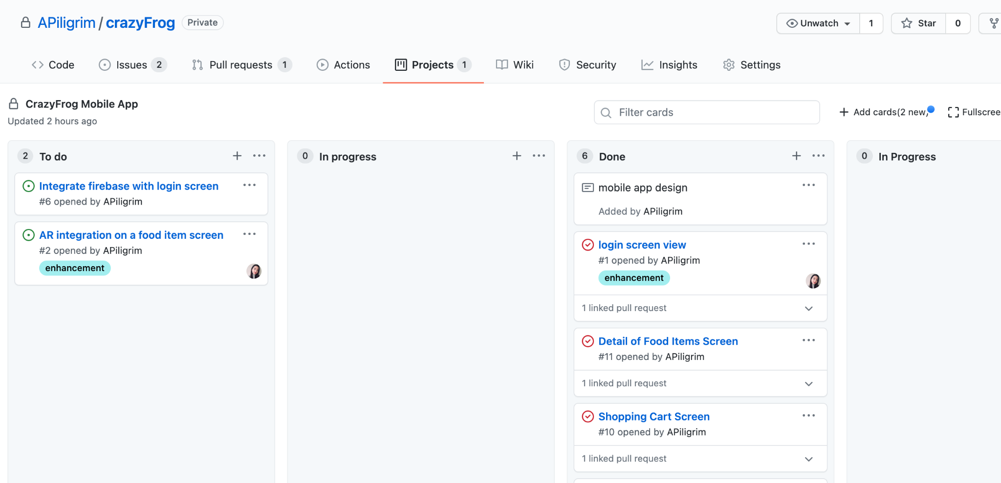

* In order to test the project, [XCode](https://apps.apple.com/us/app/xcode/id497799835?mt=12), created by Apple, must be downloaded and the project folder needs to be opened in it.
* The Views that are working & clickable prototypes are the **LoginView** and the **MainView**. The MainView has clickable items that link to other Views in the project. 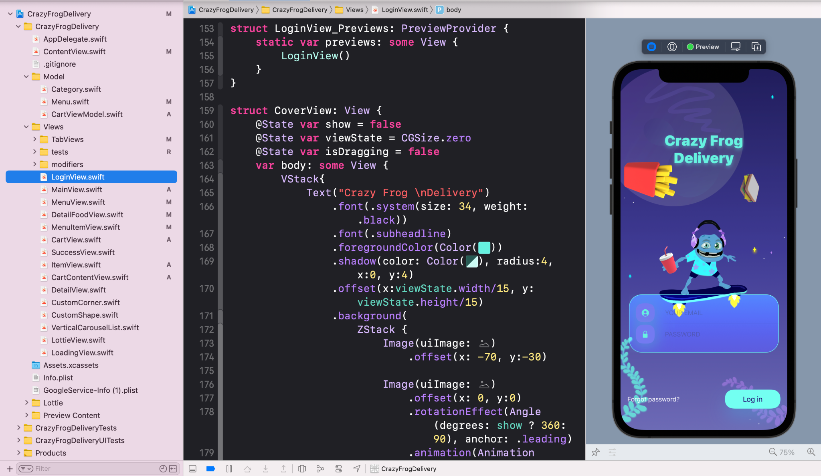
* The **Design document** with wireframes of our screens can be accessed in Figma: <https://www.figma.com/file/HBO5wZI04i2TGdBEpmPXVT/Crazy-Frog-Design-Doc?node-id=0%3A1>

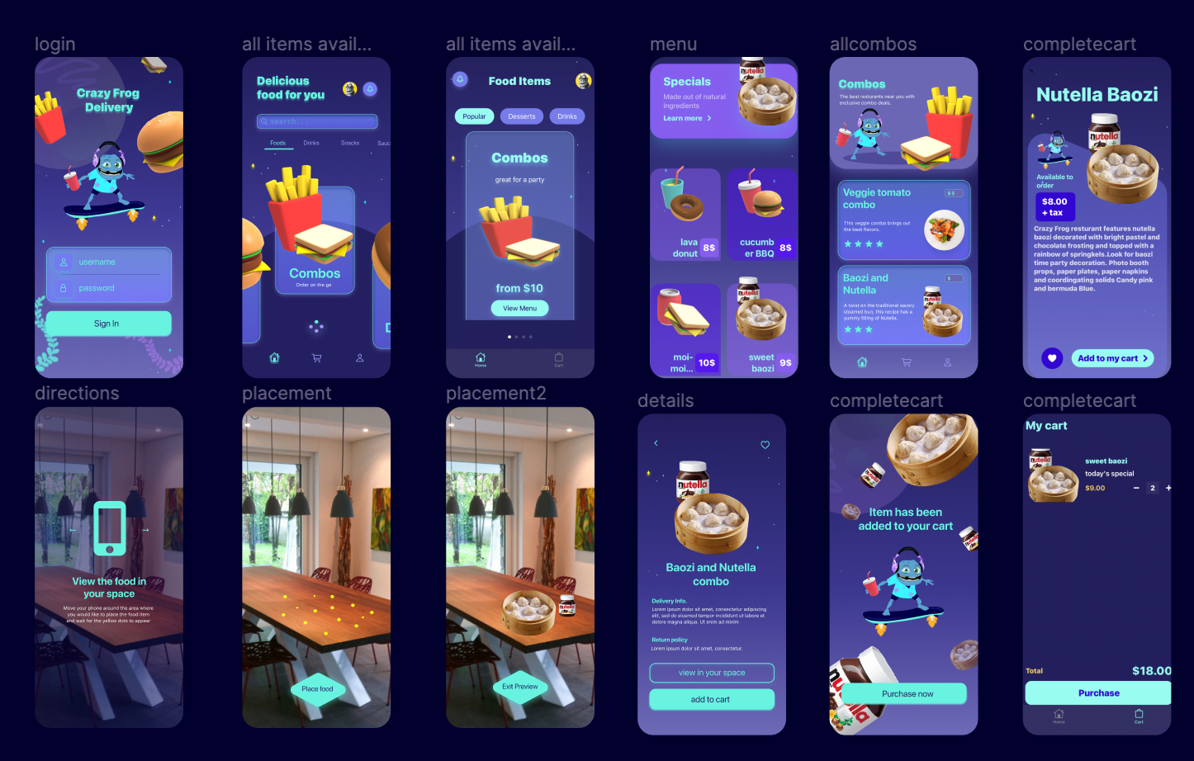

| **Lessons Learned Report (for the overall project)** |
| --- |
| **What knowledge area(s) went well, and how this was achieved?**  *Determining project scope and making a project plan were the most important areas to accomplish. These parts acted like incitements and worked as a base of the project. After they were determined, all other phases went smoothly and eventually were finished on time. To add to that, I'm incredibly proud of this team. Every team member took responsibility for a solid part of the project and executed it to the best of their ability. Each team member knew exactly what they were doing and did it very well.* |
| **What were the project challenges and how they could be addressed on another project?**  *There were communication challenges because all the team members worked remotely and were located in different time zones. Also, one member left the team in the middle of the production without notice, which made us spread the workload among a smaller number of people. In the future projects, we would try to meet more often and get more people to the team. Regarding the website, there are a lot of things that I wanted to add but some of the softwares has to be purchased so we stuck to the cheapest way out. In other projects, it will be worth purchasing to add more exciting features.* |
| **What would be done differently on a similar project?**  *As already mentioned, a similar project requires more people to be involved in the production and more time as well. Even getting the fact that the project was done on time, it would be easier if the workload is spread between more people.* |
| **What are the key takeaways about working in an IT project environment?**  *Be agile. Always keep communicating. Never stop if it’s hard: don’t lose track of the effort already spent and stay focused. Look after your team members: help each other and make each other happy. Understand your role in the project.* |

# Project Team Meeting Minutes

| **Meeting/Project Title:** | | **Crazy Frog** | | | | | | **Group Name/No.** | | | **3** | |
| --- | --- | --- | --- | --- | --- | --- | --- | --- | --- | --- | --- | --- |
| **Meeting Date: (MM/DD/YY)** | | 08/07/2021 | | | | | | **Start Time:** | | | 5:00 pm | |
| **Meeting Type:** | | **Face-to-Face __** / **Virtual +** | | | | | | **End Time:** | | | 8:00 pm | |
| **Facilitator:** | | Darya Filipchyk | | | | | | **Minutes Taker:** | | |  | |
| 1. **Meeting Objective** | | | | | | | | | | | | |
| **Finish 2nd and last Sprint. Test and Deliver the Product. Discuss Lessons learnt during the development. Fill out a close-out report.** | | | | | | | | | | | | |
| **2.** **Attendance** | | | | | | | | | | | | |
| **Name** | | | **In Attendance (Y/N)** | | | | **Reason for Absence** | | | | | |
| Darya Filipchyk | | | Y | | | |  | | | | | |
| Anastasiya Uraleva | | | Y | | | |  | | | | | |
| Akane Yasutomi | | | Y | | | |  | | | | | |
| Munira Zulka | | | Y | | | |  | | | | | |
| **3.** **Agenda, Decisions, Issues** | | | | | | | | | | | | |
| **Discussion Notes** | | | | | | | | | | **Discussion led by** | | |
| Add php to connect to database | | | | | | | | | | Akane Yasutomi | | |
| Use Apache Web server and MySQL Database | | | | | | | | | | Akane Yasutomi | | |
| **4.** **Action Item/Task Assigned** | | | | | | | | | | | | |
| **Activity** | | | | | | **Assigned To** | | | | | | **Due Date** |
| Create a deployment diagram | | | | | | Darya Filipchyk | | | | | | 08/09/2021 |
| Finish the website | | | | | | Munira Zulka | | | | | | 08/09/2021 |
| Create Power Point Presentation | | | | | | Everyone | | | | | | 08/09/2021 |
| Finish the app | | | | | | Anastasiya Uraleva | | | | | | 08/09/2021 |
|  | | | | | |  | | | | | |  |
|  | | | | | |  | | | | | |  |
| **5.** **Next Meeting** | | | | | | | | | | | | |
| **Date:** | 08/09/2021 | **Time:** | | 5:30 pm | **Meeting Type:** | | | | **Face-to-Face ____** / **Virtual +** | | | |
| **Objective:** | Present Project Phase 3 | | | | | | | | | | | |
|  |  |  |  |  |  |  |  |  |  |  |  |  |

**Project Team Members Names and Signature:**

| **Name (print)** | **Signature** | **Date** |
| --- | --- | --- |
| Darya Filipchyk | *Darya Filipchyk* | 08/09/2021 |
| Anastasiya Uraleva | *Anastasiya Uraleva* | 08/09/2021 |
| Akane Yasutomi | *Akane Yasutomi* | 08/09/2021 |
| Munira Zulka | *Munira Zulka* | 08/09/2021 |

# Project Repository

**Activity Diagram:**

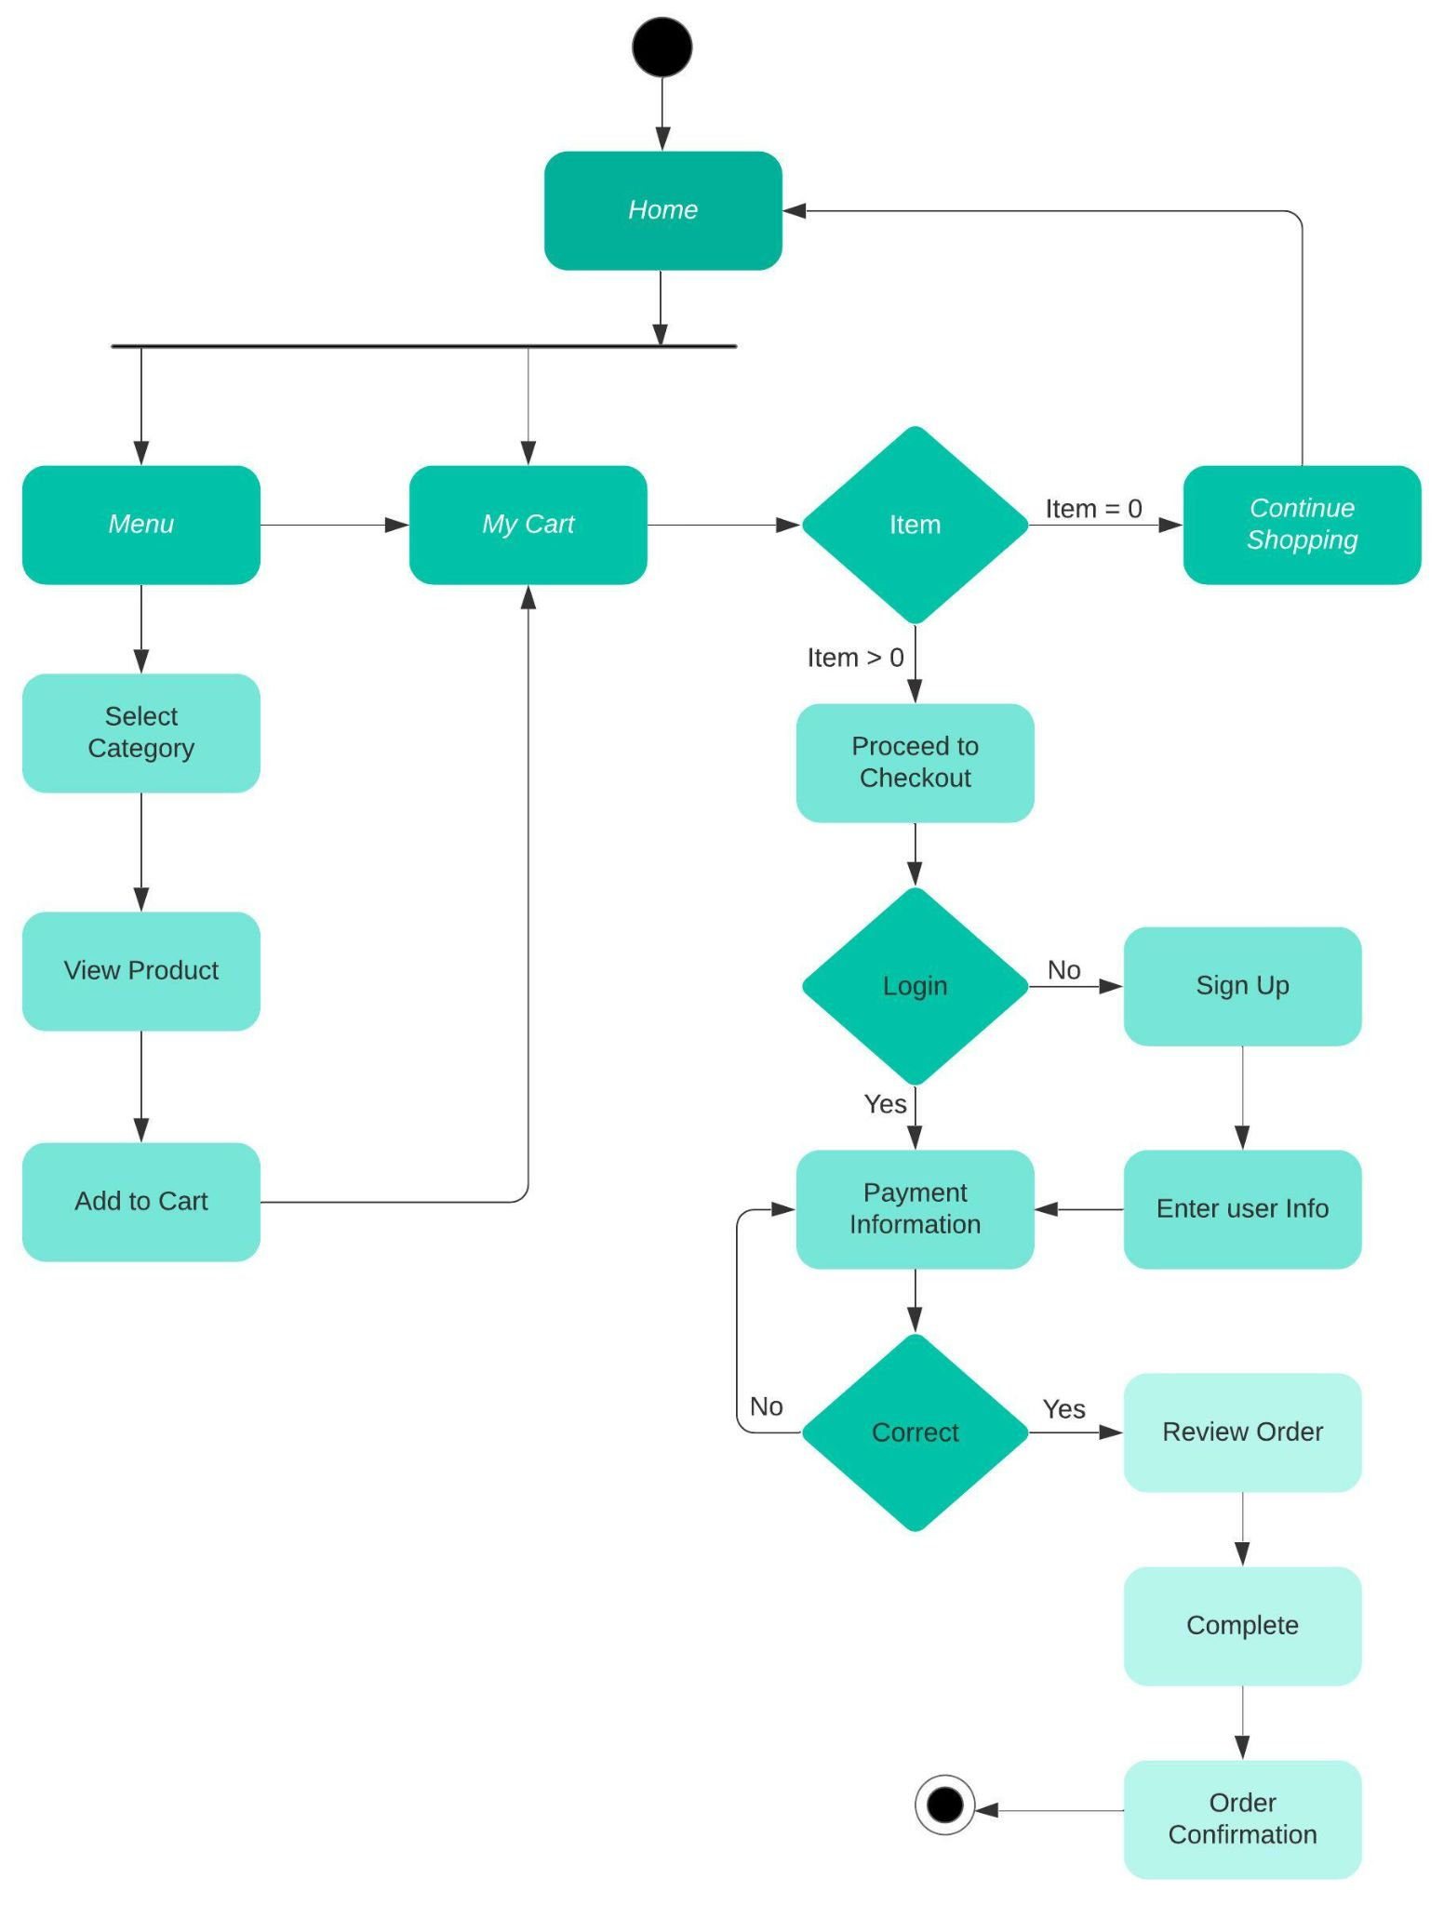

Works Cited

1. “Swiftui Complex Ui Tutorials - Paging - Carousel List - Page Control in Swiftui - Swiftui Tutorials.” *YouTube*, YouTube, 11 May 2020, www.youtube.com/watch?v=BK-8Ddtoa_w&t=7s.
2. “Swiftui Complex Ui Tutorials - Swiftui Smooth Curves - Food App - Swiftui 2.0 Tutorials.” *YouTube*, YouTube, 28 Sept. 2020, www.youtube.com/watch?v=qgbuWqXyPng.
3. Apple. “‎Xcode.” *Mac App Store*, 15 Feb. 2012, apps.apple.com/us/app/xcode/id497799835?mt=12.
4. “Where the World Builds Software.” *GitHub*, github.com/.